23.83: a) 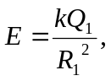 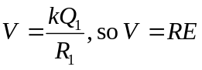
b) After electrostatic equilibrium is reached, with charge 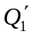 now on the original sphere we have:
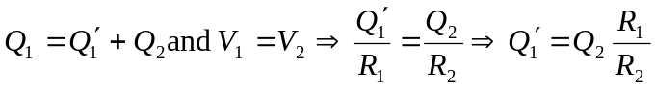
c) The new potential is the same at each sphere’s surface:
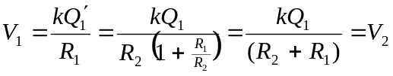
d) The new electric field is not the same at each sphere’s surface:
